**W5-S2** PRACTICE

*FORMS & INPUTS*

## *What are the objectives for this session?*

* Learn and use various **HTML form input types**
  + *text, checkbox, radio, dropdown, text area, range, color, selector etc.*
* Apply basic CSS styles to enhance the appearance of form inputs
  + *borders, colors, padding, margins etc.*
* Use:  **:focus :hover** : **checked :checked :indeterminate** CSS pseudo-classes

## *How to start?*

* Download **the start code** from the LMS
* Open the folder in VS Code

## *How to submit your work?*

* **Push** your final codeon **your GitHub repository**
* Then **attach the GitHub path** to the MS Team assignment and **turn it in**

## *Are you lost?*

*You can read the following documentation to be ready for this practice:*

* [Guide - WC3 School](https://www.w3schools.com/html/html_forms.asp)
* [The Form element](https://developer.mozilla.org/en-US/docs/Web/HTML/Element/form)
* [HTML Forms](https://www.geeksforgeeks.org/html-forms/)

# **PART 1:** LEARN – 45 MIN

* **Read or watch** resources on internet to learn about **HTML Inputs**:

[Guide - WC3 School](https://www.w3schools.com/html/html_forms.asp)

[The Form element](https://developer.mozilla.org/en-US/docs/Web/HTML/Element/form)

[HTML Forms](https://www.geeksforgeeks.org/html-forms/)

* **Complete** the bellow table.

|  |  |  |
| --- | --- | --- |
| **INPUT TYPE** | **USAGE** | **EXAMPLE** |
| Text | defines a one-line input field for text input | <input type="text"> |
| radio | Displays a radio button | <input type="radio"> |
| checkbox | Displays a checkbox | <input type="checkbox"> |
| range | Define a range control | <input type="range"> |
| submit | Displays a submit button | <input type="submit"> |
| textarea | A multi-line text input control | <textarea> </textarea> |
| select | A drop-down list located outside a form | <select> </select> |
| color | Show a color picker | <input type="color"> |
| file | let the user choose one or more files from their device storage. | <input type="file"> |

* **Read or watch** resources on internet to learn about  **Inputs styling**:

<https://www.w3schools.com/css/css_form.asp>

* Complete those **mini-challenges** by writing your code on bellow table:

|  |  |
| --- | --- |
| **MINI CHALLENGES** | **YOUR CODE (HTML + CSS)** |
| Highlight the input field when it is focused | <!DOCTYPE html>  <html lang="en">    <head>      <meta charset="UTF-8" />      <meta name="viewport" content="width=device-width, initial-scale=1.0" />      <title>Document</title>    </head>    <style>        .highlight-on-focus:focus {        background-color: rgb(99, 94, 94);        border: 1px solid gray;        transition: ease;      }      .highlight-on-focus:hover {        border-color: gray;        border: 1px solid whiteblack;        transition: ease;      }      .highlight-on-focus {        border: 1px solid black;      }    </style>    <body>      <form action="name">        <label for="">first name: </label>        <input          type="text"          class="highlight-on-focus"          placeholder="Type here...."        />      </form>      <br>      <form action="name">          <label for="">Last name: </label>          <input            type="text"            class="highlight-on-focus"            placeholder="Type here...."          />        </form>    </body>  </html> |
| Change the button background color on hover | <!DOCTYPE html>  <html lang="en">    <head>      <meta charset="UTF-8" />      <meta name="viewport" content="width=device-width, initial-scale=1.0" />      <title>Document</title>    </head>      <style>      body{          display: flex;          justify-content: center;          align-items: center;          height: 100vh;          width: 100%;      }      .styled {        background-color: rgb(255 0 0 / 100%);        padding: 10px;        border-radius: 30px;        border-style: none;        color: white;        box-shadow: 0 0 10px rgba(209, 231, 10, 0.959);      }        .styled:hover {          background-color: rgb(221, 207, 11);          cursor: pointer;          color: black;          box-shadow: 0 0 10px rgba(245, 0, 0, 0.959);          transition: 0.2s ease;          }    </style>    <body>      <form action="">        <input class="styled" type="button" value="Add to favorites" />      </form>    </body>  </html> |
| Create a search bar with rounded corners and a shadow effect | <!DOCTYPE html>  <html lang="en">    <head>      <meta charset="UTF-8" />      <meta name="viewport" content="width=device-width, initial-scale=1.0" />      <title>Document</title>    </head>    <style>        .search-bar {          padding: 10px;          border-radius: 30px;          border: 1px solid black;        }        .search-bar:focus {            box-shadow: 0 0 5px rgba(20, 20, 20, 0.959);          transition: 0.2s ease;          background-color: rgb(206, 204, 204);        }        .search-bar:hover {            box-shadow: 0 0 5px rgba(20, 20, 20, 0.959);          transition: 0.2s ease;        }        </style>    <body>      <form action="">        <input type="text" class="search-bar" placeholder="Search..." />      </form>    </body>  </html> |
| Display a different style when the checkbox is checked | <!DOCTYPE html>  <html lang="en">  <head>      <meta charset="UTF-8">      <meta name="viewport" content="width=device-width, initial-scale=1.0">      <title>Document</title>  </head>  <style>      input[type="checkbox"]:checked + label {          color: red;        }          input[type="checkbox"] {          color: #fff;          transition: all 0.2s;          box-shadow: 0 0 5px rgb(121, 113, 113);        }  </style>  <body>      <form>          <input type="checkbox" />          <label for="vehicle1"> I am Dara</label><br />          <input type="checkbox" />          <label for="vehicle2"> I am Ilong</label><br />          <input type="checkbox" />          <label for="vehicle3"> I am Terry</label>        </form>  </body>  </html> |
| **HARD!**  Style a checkbox to have three states: unchecked, checked, and indeterminate.  TIP  Use CSS pseudo-classes  (:checked and :indeterminate)  for styling. | <!DOCTYPE html>  <html lang="en">  <head>      <meta charset="UTF-8">      <meta name="viewport" content="width=device-width, initial-scale=1.0">      <title>Checkbox Styling</title>      <style>          input[type="checkbox"]:checked + label {              color: red;          }          input[type="checkbox"] {              color: #0fe221bd;              transition: all 0.2s;              box-shadow: 0 0 5px rgb(121, 113, 113);          }          label {              color: green;          }      </style>  </head>  <body>      <form>          <input type="checkbox" id="vehicle1" />          <label for="vehicle1"> I am Dara</label><br />          <input type="checkbox" id="vehicle2" />          <label for="vehicle2"> I am Ilong</label><br />          <input type="checkbox" id="vehicle3" />          <label for="vehicle3"> I am Terry</label>      </form>      <script>            var checkbox = document.getElementById("vehicle1");          checkbox.indeterminate = true;      </script>  </body>  </html> |

* Some **groups will be selected to present** and **explain** their work to the whole class

# **PART 2:** PRACTICE – 45 MIN

You need to reproduce – *as close as possible* - the bellow table.

Before coding, identify the following point:

* **Elements**: What are the different inputs you will need?
* **Layout**: what kind of CSS layout do you need? Why?
* **Input styling**: What are the styles you need to apply on your inputs?

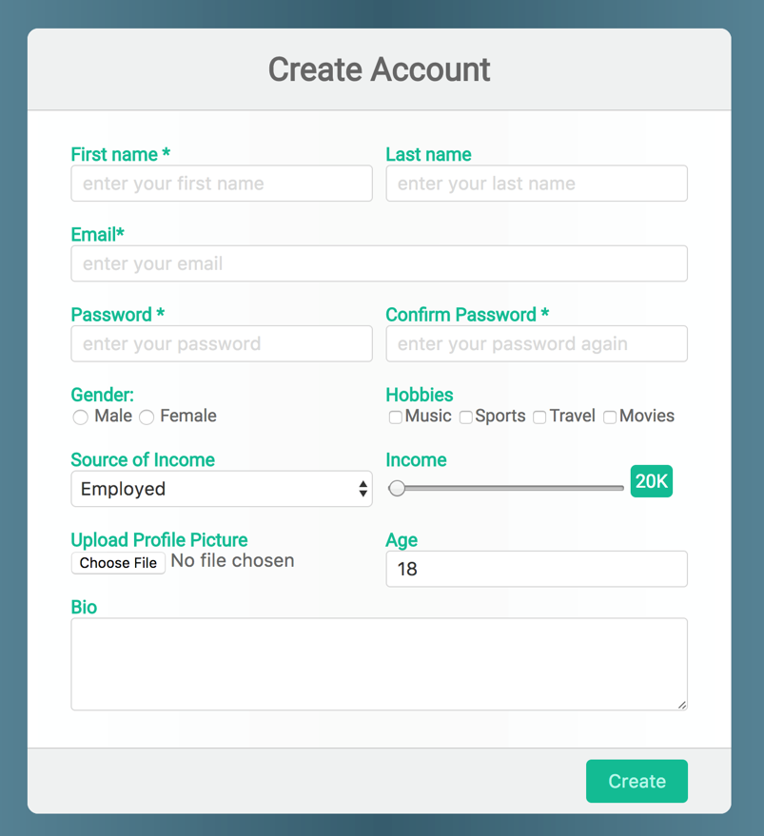

*Be as close as possible from this mock up*

# **PART 3:** THINK + PAIR + SHARE – 90 MIN

***STEP 1: INDIVIDUAL WORK*** *– 15 MIN*

1. Brainstorm a **form idea** based on a *scenario*

*e.g., contact form, login form, survey form, registration form…*

1. List the **elements** you think the form should include

*e.g.: text area, password, color selector, radio button, list…*

1. List any **specific CSS styles** the form should have

*e.g., hover effects, focus styles, alignment, layout, columns, rows…*

***STEP 2: COLLABORATIVE WORK*** *– 45 MIN*

1. Decide on a **single form idea** to develop.
2. **Sketch the form structure** and styling on paper
3. Start implementing the **HTML** structure and **CSS** styles collaboratively.

***STEP 3: SHARE*** *– 30 MIN*

* Pair with another team and demonstrates your project, explaining:
  + The **form’s purpose** and use case
  + How you structured the **HTML**
  + The **CSS** techniques used for styling
  + The **challenges you have faced** and how you resolved them
* Some **groups will be selected to present** their work to the whole class